


SAVEETHA INSTITUTE OF MEDICAL AND TECHNICAL SCIENCES (SIMATS)
Saveetha School of Engineering
Department of Computer Science and Engineering
SOFTWARE ENGINEERING
CI/CD Pipeline Design
TITLE : Design and Development of an Online Auction System with Real-Time Bidding

Submitted By
Name : Akileshwaran A
Register Number : 192511354
GUIDED BY

Course Faculty : Dr. K. ANITADAVAMANI

SIMATS ENGINEERING
Saveetha Institute of Medical and Technical Sciences Chennai – 602105
August- 2026
SNO | CONTENT | PAGE NO
1 | Problem Statement & Project Overview | 3
2 | Analysis of CI/CD Requirements | 4
3 | CI/CD Pipeline Architecture & Workflow Diagram | 5
4 | Tools & Technology Selection | 8
5 | Automated Testing Strategy | 9
6 | Deployment Strategy & Environments | 10
7 | Security & Quality Gates | 11
8 | Real-Time Bid Request Flow (Sequence Diagram) | 12
9 | Conclusion | 12
TABLE OF CONTENTS

1. Problem Statement & Project Overview
The assigned problem statement is an Online Auction System supporting real-time bidding, where multiple users bid concurrently on live listings and see bid updates instantly. The system requires a web/mobile front end, a backend API layer, a real-time messaging component (WebSockets) for live bid broadcasts, a relational/NoSQL data layer for listings, bids, and payments, and integration with third-party services such as payment gateways and notification services.
Because bidding is time- and concurrency-sensitive, the CI/CD pipeline must validate correctness under concurrent load, protect against race conditions on bid placement, guarantee zero/near-zero downtime deployments, and support fast rollback if a release introduces a defect during a live auction.

2. Analysis of CI/CD Requirements
Based on the nature of the application, the following CI/CD needs were identified:
- Frequent, safe integration of code from multiple developers (frontend, backend, real-time bidding service) without breaking the live bidding flow.
- Automated build and containerization of each microservice (User Service, Auction/Listing Service, Bidding Service, Payment Service, Notification Service).
- Automated functional, concurrency, and load testing to verify the bidding engine behaves correctly when many users bid on the same item simultaneously.
- Static code analysis and security scanning, since the system handles payments and personal user data.
- Environment parity across development, staging, and production to avoid “works on staging, fails in production” issues.
- Zero-downtime deployment strategy (blue-green/canary) since auctions run continuously and cannot be taken offline for standard releases.
- Real-time monitoring, alerting, and automated rollback in case a deployment degrades bid latency or causes errors.

3. CI/CD Pipeline Architecture & Workflow Diagram
The diagram below illustrates the end-to-end pipeline from code commit to production deployment, including the environment progression and the rollback/monitoring loop.
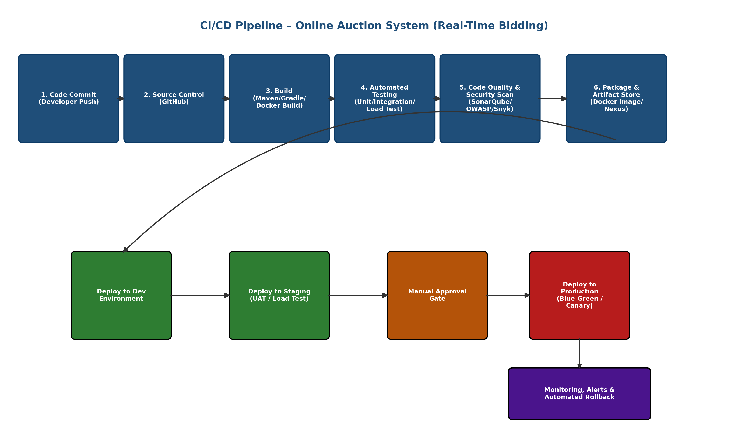
Figure 1: CI/CD Pipeline for the Online Auction System (Real-Time Bidding)

3.1 Workflow Explanation (Commit to Deployment)
- Code Commit: A developer pushes code (e.g., a fix to the Bidding Service) to a feature branch and opens a pull request.
- Source Control: GitHub triggers a webhook to the CI server on every push/PR to main or a release branch.
- Build: The pipeline compiles each microservice and builds Docker images; dependency resolution and versioning happen here.
- Automated Testing: Unit tests, integration tests, and a concurrency/load test suite specifically simulate multiple simultaneous bids on the same auction item to catch race conditions.
- Code Quality & Security Scan: Static analysis, dependency vulnerability scanning, and secrets scanning run before packaging, since payment data is involved.
- Package & Artifact Store: Verified builds are tagged and pushed as immutable Docker images to a container registry.
- Deploy to Dev: Every merge to the develop branch auto-deploys to the Dev environment for early integration checks.
- Deploy to Staging: Release-candidate builds deploy to Staging, where UAT and full-scale load testing simulate peak auction traffic (e.g., last-minute bidding surges).
- Manual Approval Gate: A release manager reviews test/security reports and approves promotion to production.
- Deploy to Production: A blue-green or canary strategy shifts live traffic gradually, keeping the previous version warm for instant rollback.
- Monitoring & Rollback: Post-deployment, dashboards track bid latency, WebSocket connection health, and error rates; automated rollback triggers if thresholds are breached.

3.2 Sample Pipeline Configuration (GitHub Actions)
A simplified workflow file illustrating how the Bidding Service stages above would be encoded in practice:
name: bidding-service-ci-cd
on:
push:
branches: [develop, release/*]

jobs:
build-test-scan:
runs-on: ubuntu-latest
steps:
- uses: actions/checkout@v4
- name: Build & unit test
run: mvn clean verify
- name: Concurrency / load test
run: k6 run tests/bid-concurrency.js
- name: Code quality scan
run: sonar-scanner
- name: Dependency & secret scan
run: snyk test && gitleaks detect
- name: Build & push Docker image
run: |
docker build -t registry/bidding-service:${{ github.sha }} .
docker push registry/bidding-service:${{ github.sha }}

deploy-staging:
needs: build-test-scan
runs-on: ubuntu-latest
steps:
- name: Helm upgrade (staging)
run: helm upgrade bidding-service ./chart -f values-staging.yaml

deploy-production:
needs: deploy-staging
environment: production # requires manual approval
runs-on: ubuntu-latest
steps:
- name: Canary rollout
run: helm upgrade bidding-service ./chart -f values-prod.yaml --set canary.weight=10
Figure 2: Sample CI/CD workflow definition for the Bidding Service

4. Tools & Technology Selection
The following tools were selected for each pipeline stage, with justification specific to a real-time, payment-integrated auction platform:
Stage | Recommended Tool(s) | Justification
Source Code Mgmt | GitHub / GitLab, Git branching (GitFlow) | Industry-standard version control; PR-based review suits a multi-service team and protects the live bidding branch.
CI Orchestration | Jenkins / GitHub Actions | Wide plugin ecosystem, native Docker/Kubernetes support, and easy webhook triggers on commit/PR.
Build & Package | Maven/Gradle (Java) or npm (Node.js) + Docker | Consistent, reproducible builds; Docker ensures each microservice runs identically across environments.
Automated Testing | JUnit/Mocha (unit), Postman/Newman (API/integration), JMeter/k6 (concurrency & load) | JMeter/k6 specifically stress-tests simultaneous bidding to catch race conditions before release.
Code Quality | SonarQube | Detects code smells, duplication, and maintainability issues early, keeping the bidding engine reliable.
Security Scanning | OWASP Dependency-Check / Snyk, GitLeaks | Essential since the system processes payments and personal data; scans dependencies and blocks committed secrets.
Artifact Repository | Docker Hub / Nexus / Amazon ECR | Stores versioned, immutable images so any release can be redeployed or rolled back exactly.
Deployment / Orchestration | Kubernetes + Helm | Enables blue-green/canary rollouts and auto-scaling to absorb bidding traffic spikes near auction close.
Monitoring & Alerting | Prometheus + Grafana, ELK Stack | Real-time dashboards for bid latency and WebSocket health; ELK centralizes logs for fast incident diagnosis.
Notifications | Slack / Email / MS Teams webhook integration | Immediately informs the team of pipeline failures or production alerts.

5. Automated Testing Strategy
Testing is layered so that defects are caught as early and cheaply as possible, with special emphasis on concurrency correctness for the bidding engine:
Test Level | What It Validates | Tools | Pipeline Stage
Unit Testing | Individual functions (e.g., bid validation logic, price calculation) | JUnit / Jest / Mocha | Build
Integration Testing | Service-to-service calls (Bidding ↔ Payment ↔ Notification APIs) | Postman/Newman, Testcontainers | Post-build
Concurrency Testing | Multiple simultaneous bids on the same item; race-condition and lock handling | JMeter, k6, custom scripts | Pre-staging
Load / Performance Testing | System behaviour under peak auction-closing traffic spikes | JMeter, k6, Gatling | Staging
Security Testing (SAST/DAST) | Vulnerabilities, injection flaws, exposed secrets, dependency CVEs | SonarQube, OWASP ZAP, Snyk | Post-build / Pre-deploy
User Acceptance Testing (UAT) | End-to-end bidding, checkout, and notification flows from a user perspective | Manual + Selenium/Cypress | Staging
Smoke Testing | Critical paths (login, place bid, payment) work after each production deploy | Cypress / Postman | Post-deploy (Production)

6. Deployment Strategy & Environments
Environment | Purpose | Deployment Trigger | Notes
Development | Early integration testing for feature branches | Auto-deploy on merge to develop | Uses mocked payment gateway; low-cost infra
Testing / Staging | Full UAT, load, and security validation before release | Auto-deploy on release-candidate tag | Mirrors production configuration and scale as closely as possible
Production | Live auction platform serving real users | Manual approval gate, then automated blue-green/canary rollout | Traffic shifted gradually (e.g., 10% → 50% → 100%) while monitoring bid latency and error rate

6.1 Rollback Mechanism
- Blue-Green Deployment: The previous stable version stays live (idle) during release; traffic is switched back instantly if errors spike.
- Canary Releases: New versions first receive a small percentage of live bidding traffic; automatic rollback triggers if error rate or bid latency exceeds a defined threshold.
- Immutable Artifacts: Every deployed image is versioned in the artifact registry, allowing any prior version to be redeployed on demand.
- Database Migration Safety: Backward-compatible, reversible database migrations are used so a rollback of application code does not break the schema.

7. Security & Quality Gates
- Mandatory code review (pull request approval) before merge to protected branches.
- Static Application Security Testing (SAST) and dependency vulnerability scans must pass before packaging.
- Secrets management via a vault (e.g., HashiCorp Vault / cloud secrets manager) — no credentials in source or config files.
- Dynamic Application Security Testing (DAST) against the staging environment before production promotion, given the payment integration.
- SonarQube quality gate (coverage, duplication, critical issues) must pass before a build can be promoted.
- Pipeline and deployment notifications sent to the team via Slack/Email on every failure or successful production release.

8. Real-Time Bid Request Flow (Sequence Diagram)
Since correctness under concurrent bidding is the system's central risk, the sequence diagram below traces a single bid request end-to-end, showing exactly where the pipeline's concurrency testing (Section 5) must apply pressure.
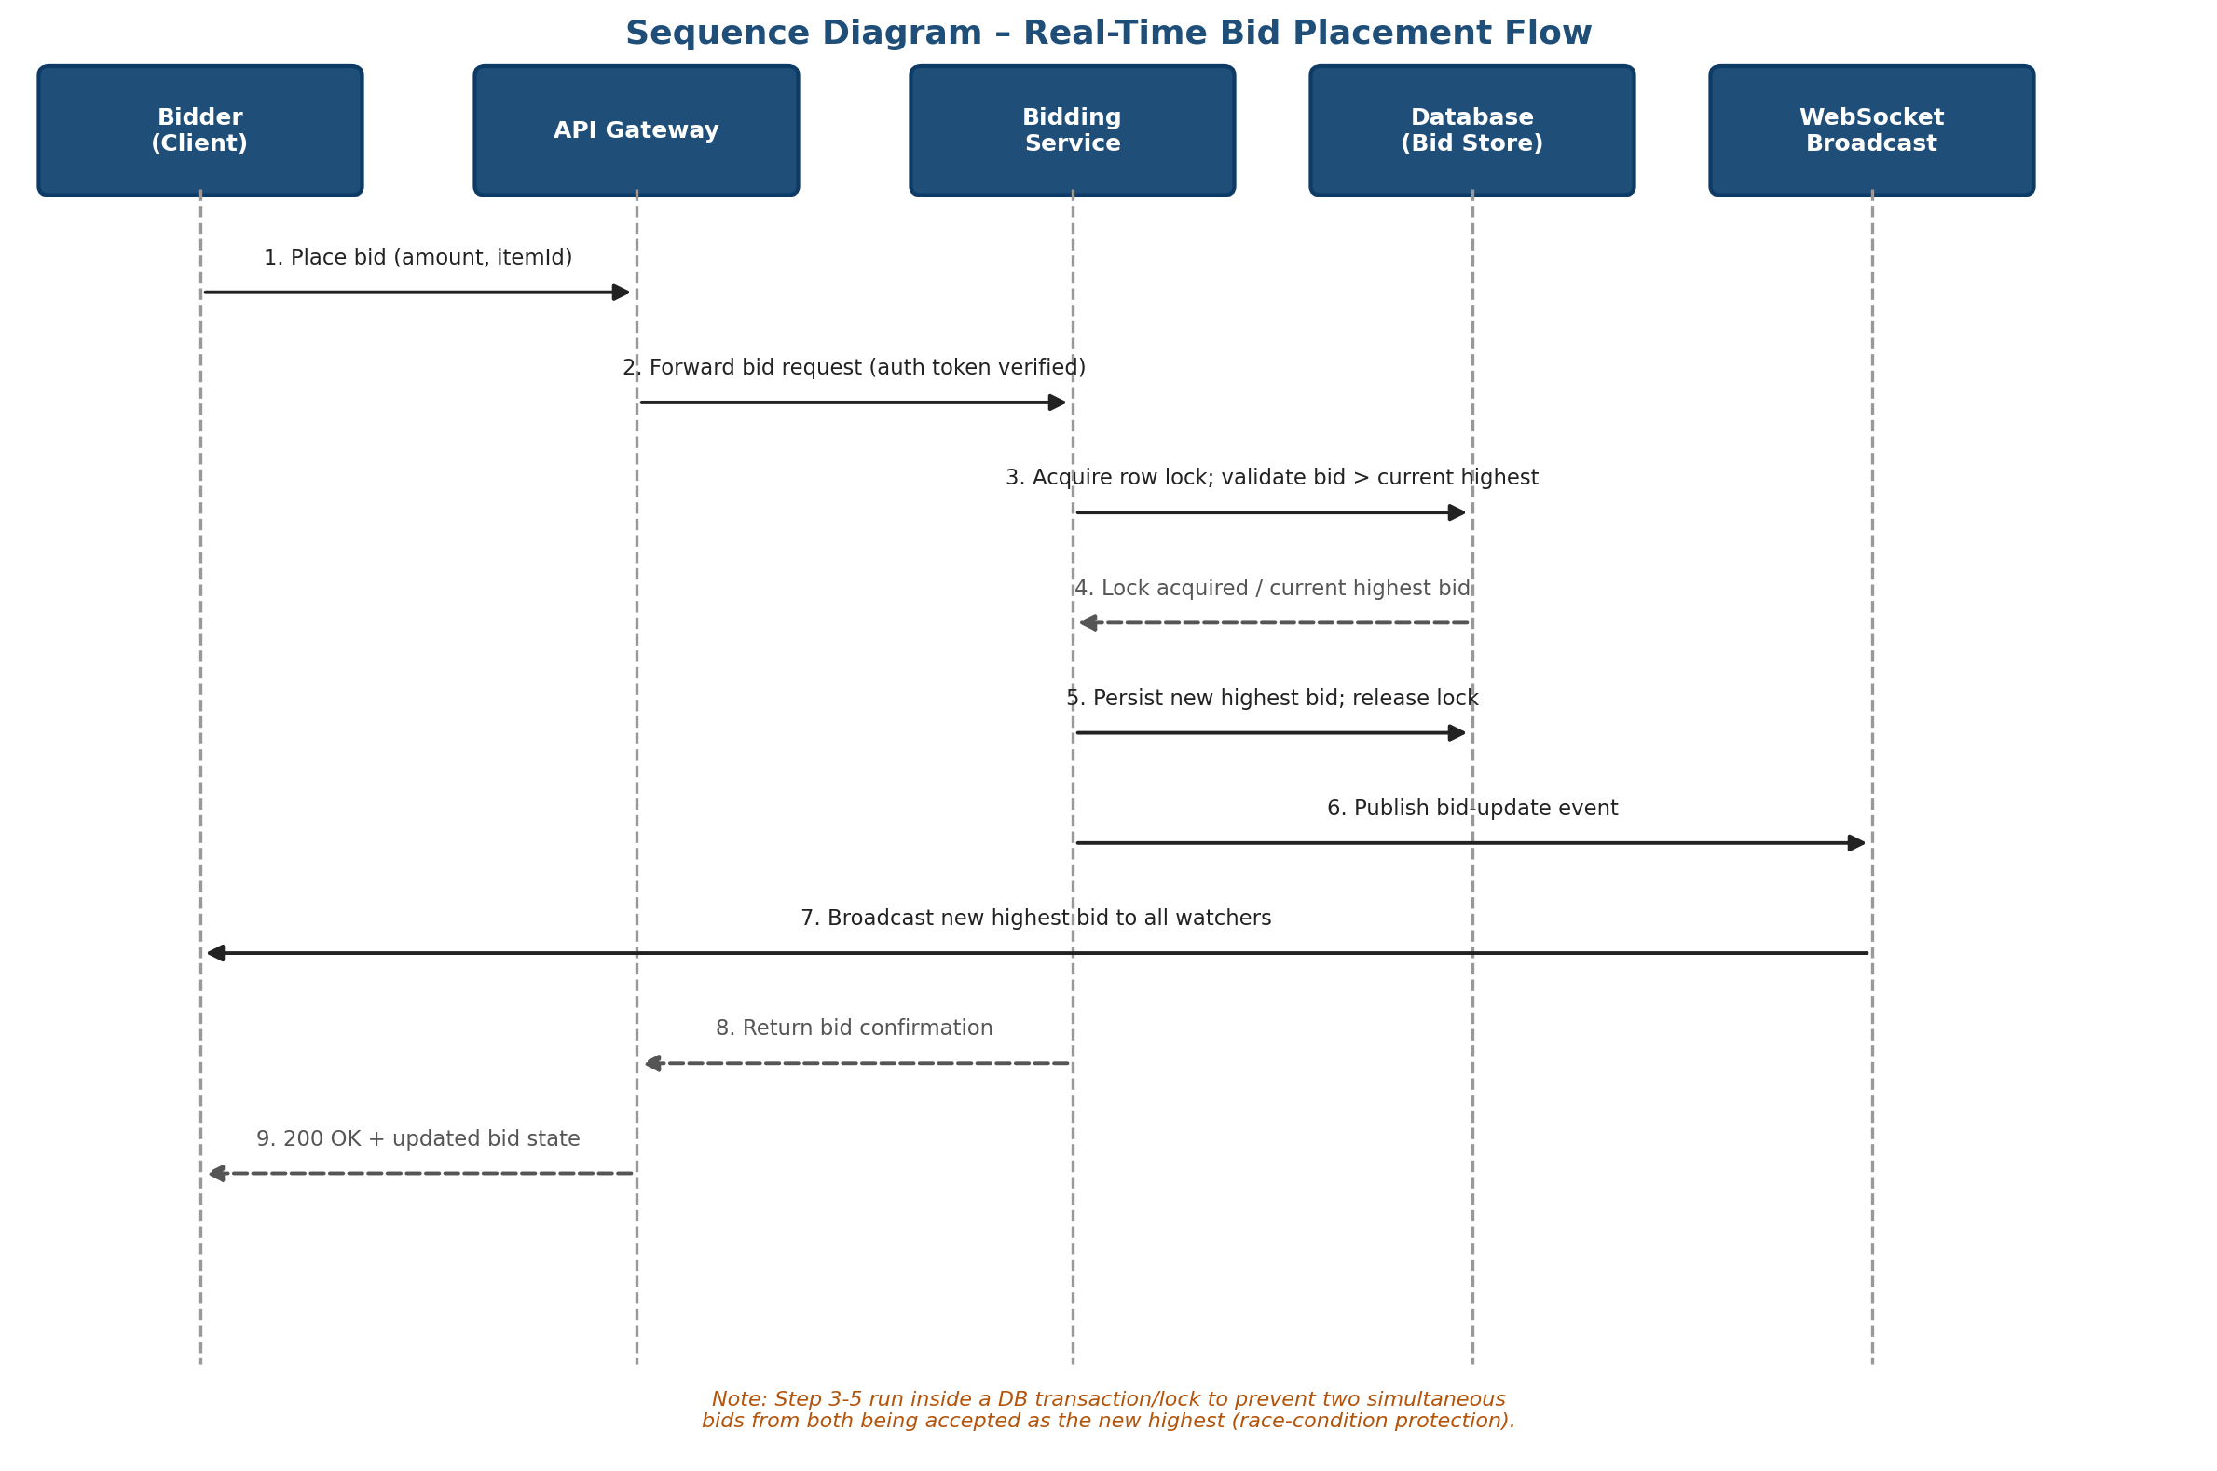
Figure 3: Sequence diagram of a real-time bid placement, from client request to broadcast

9. Conclusion
The proposed CI/CD pipeline automates the Online Auction System's journey from code commit to production, with concurrency-aware automated testing, integrated security and code-quality gates, a zero-downtime blue-green/canary deployment strategy, and real-time monitoring with automated rollback. This design directly addresses the platform's core risk — maintaining correctness and availability of real-time bidding under concurrent, high-traffic conditions — while meeting CO4's emphasis on security, reliability, and DevOps best practice.

